Week 07

# Question 01:

# 

# 

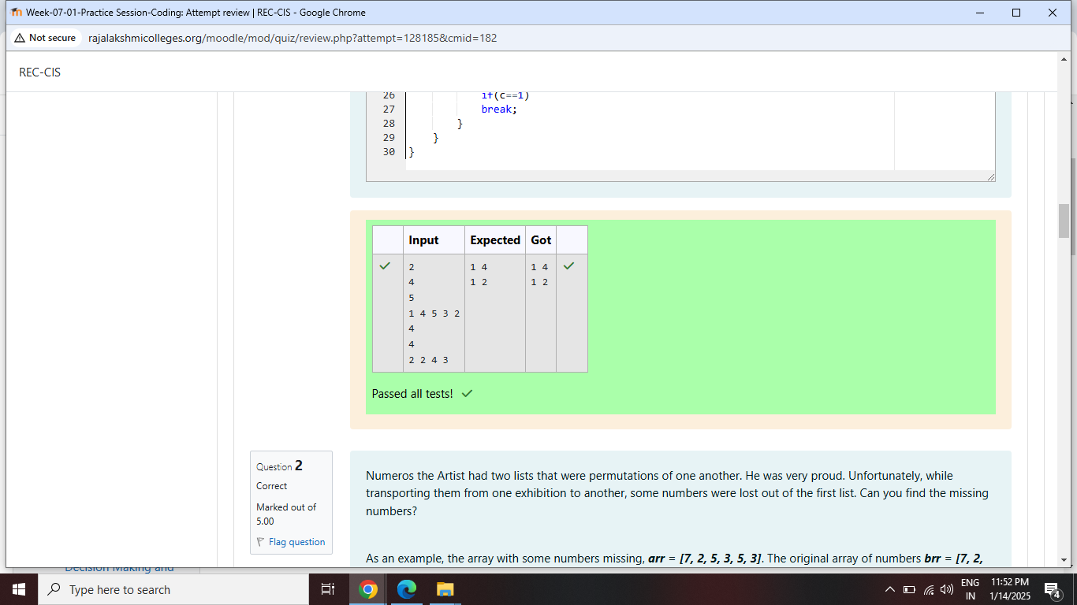

# Question 02:

# 

# 

# 

# Question 03:



 